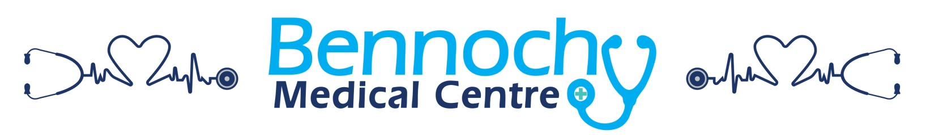
NEW PATIENT MEDICAL FORM

Name: Date:

Address: Postcode:

D.O.B. Home /Mobile No: Email:
Next of Kin 1: Contact Number:

Do you look after someone who is ill, frail or mentally ill? YES/NO
Are you a young carer? YES/NO
Does someone look after you? YES/NO
In times of an emergency, do you want important medical and medication details made available to
NHS 24/A&E/Ambulance Service: YES/NO*
*If you are unsure, more information is available: http://www.gov.scot/Resource/Doc/143714/0036499.pdf
ETHNIC ORIGIN
A. White - Scottish English Irish Welsh British Other White background, please specify
B. Mixed - Any Mixed background, please specify
C. Asian, Asian Scottish, Asian English, Asian Welsh or other Asian British - Indian Chinese Pakistani Bangladeshi Any other Asian background, please specify
D. Black, Black Scottish, Black English, Black Welsh or other Black British - Caribbean African Any other black background, please specify
E. Other ethnic background - Any other black background, please
F. Unknown -
Do you require an interpreter or sign language support? Yes No
If you need an interpreter what language do they speak? Please state

PERSONAL MEDICAL HISTORY
Do you currently smoke: Yes No If Yes, how many cigarettes/how much tobacco:_

Have you ever smoked – if yes, for how long and when did you stop:

ALCOHOL No Yes units per week
EXERCISE Physically Impossible Light Moderate Heavy

Please list and date any significant illness, accidents or operations you have had in the past:

Do you take regular medicine, if yes please list names and reason for taking

Is there anything e.g. a medicine you are allergic to [If yes, please state preparation and type of allergic reaction]

Family History
Asthma Yes No If Yes, which family member
Stroke Yes No If Yes, which family member
Heart Attack Yes No If Yes, which family member
High Blood Pressure Yes No If Yes, which family member
Diabetes Yes No If Yes, which family member
Is there anything else you think would be useful for us to know about you? – If so, please detail on the other side:

